# Introduction

[**DigiWallet**](http://www.digiwallet.nl) is a payment service provider in the Netherlands. Digiwallet ensures that your customers can pay simple, safe and fast in your web shop. With payment methods such as iDEAL (The Netherlands), Bancontact (Belgium), SOFORT (Germany) and Credit Card we have been supporting online retailers, institutions and charity organizations since 1995. Besides these payment methods DigiWallet offers the DigiWallet Suite. Useful solutions, such as E-Giro, E-Invoices and E-Plugins, which can be used directly with your DigiWallet account for free.

Payments via Payment Service Provider (PSP) DigiWallet are safe and secure. DigiWallet is part of the TargetMedia group, a company with more than 22 years of experience in realizing online solutions. In these years they have already processed more than 250 million payments. TargetMedia, and thereby DigiWallet, are in possession of a license from the Dutch National Bank. Furthermore they are certified by Currence iDEAL B.V. for facilitating iDEAL transactions.

In addition to the legal requirements that are imposed on the PSP, DigiWallet carries out some important policy rules/ guarantees:

* DigiWallet will never invest or lend your money.
* DigiWallet will never use your money to pay other customers faster.

Your money is your money.

**In order to use the DigiWallet Magento plugin you have to setup a DigiWallet account. The account should be set-up and completed before the installation. You can create an account** [here](https://www.digiwallet.nl/).

## **Description**

With the digiwallet extension you can add different payment methods for different countries

to your webstore, Including refunds .

Supported payment methods are :

* iDEAL ( the Netherlands)
* Bancontact (Belgium)
* SOFORT Banking (Mostly Germany but also many other European countries)
* GiroPay
* EPS
* Credit cards (worldwide)
* Paysafecard (50+ countries)
* PayPal (worldwide)
* Direct Debit (10+ countries)
* Bank Transfer (worldwide)

To make it clear how it is presented in your store here is an example

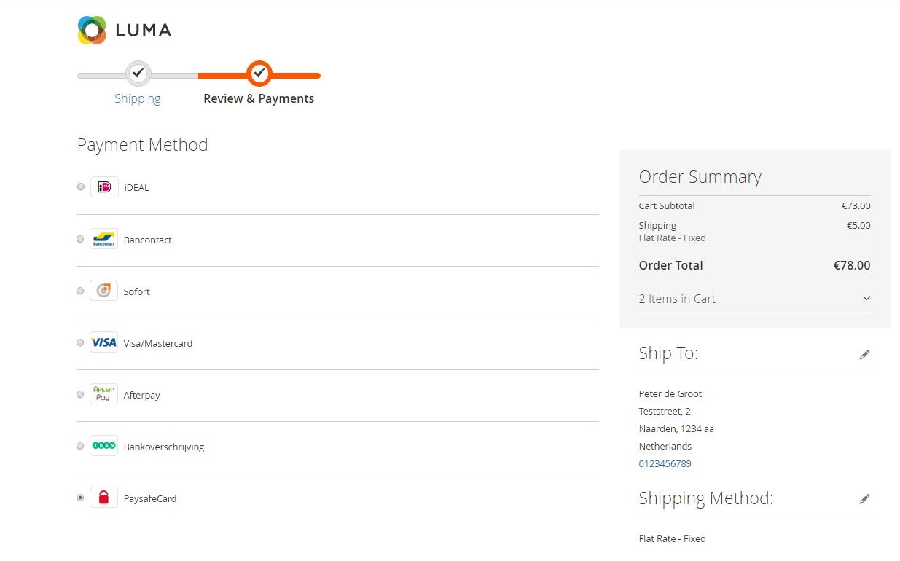

**Benefits**

* An easy to use dashboard with a complete overview of all your transactions
* One solution for all your different payments
* The Digiwallet extension provides the online retailer as well as the consumer a user friendly and safe payment experience, resulting in higher conversion rates and customer satisfaction.
* Easy pricing model
* Possibility of refunds
* Easy to use testpanel 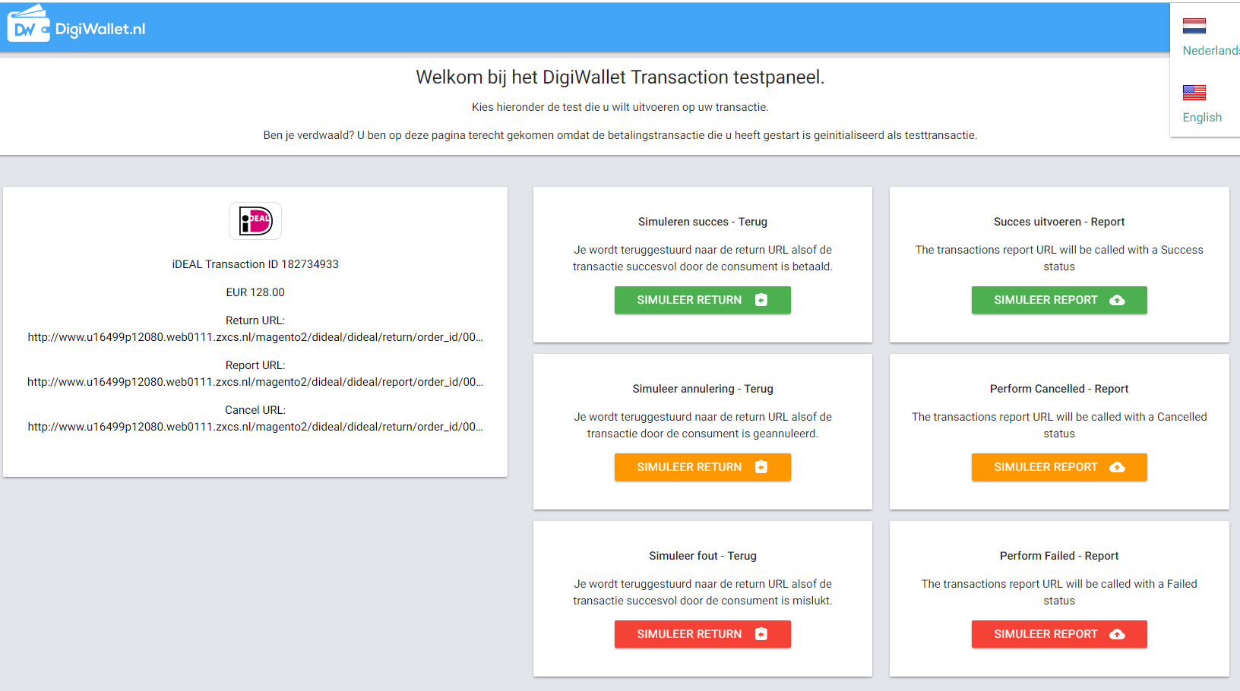
* Easy to install and configure

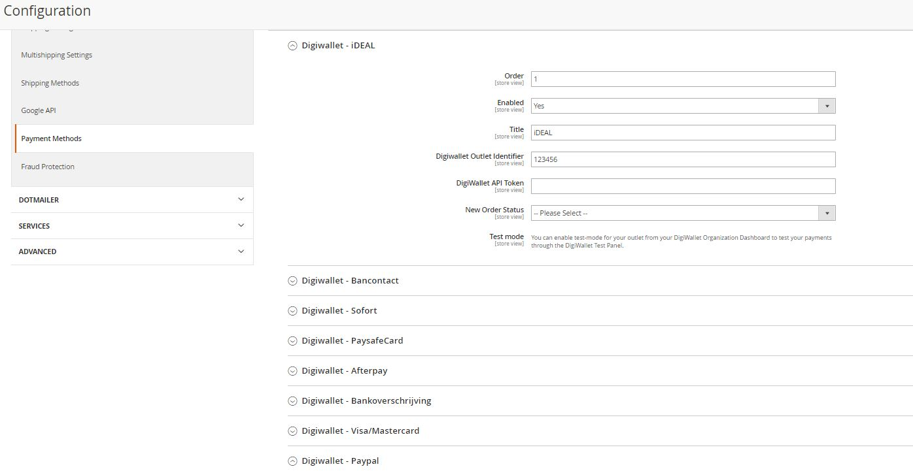

## Account & Pricing

The DigiWallet extension for Magento can be used free of charge by online retailers and webstores. The easy-to-install plugin can be used to initiate and complete payments. When the consumer wants to pay, they go to the checkout page. This is the moment when DigiWallet comes in. The consumer can choose which payment method they want to pay with. The merchant choose the range of payment methods on your website yourself. The payments are handled in their own safe payment environment. After the payment the consumer is redirected to the merchants webstore.

The DigiWallet payment module will seamlessly integrate into your Magento payment structure. Easily process payments in your Magento store via DigiWallet. Manage your transactions easily from the backend of your store (capturing, cancelation, refund).

For the account there are no start-up or monthly expense. You only pay fees for the successful transactions. These fees vary based on payment method and the number of transactions per month. Details about the pricing can be found [here](https://www.digiwallet.nl/nl/paymethods/).

## Security

Digiwallet is fully PCI compliant

The extension allows the merchant, using their unique credentials to connect to the Digiwallet payment platform. The connection is made using an API over a secure SSL connection The customer selected payment method is completed over the API, with no customer specific payment information being stored through the plugin on the merchant's system. The customer is redirected The payments are handled in their own safe payment environment. So no payment specific data is stored on your server. After the payment the consumer is redirected to the merchants webstore.

## Release information

Compatible with Magento 2.0 - 2.3.6

Version 1.1.0 Afterpay calculation bug

Version 1.0.9 Minor bug fixes

Version 1.0.8 Two payment methods added / Changed iDEAL logo

Version 1.0.7 Minor changes

Version 1.0.6 add translation errorcodes for multi language

Version 1.0.5 add option to turn off Invoice

Version 1.0.4 minor bug fixes and URL update

Version 1.0.3 first version for marketplace

Version 1.0.2 Split up payment modules

Version 1.0.1 Complete rebuild to new standards